NATIONAL SELF-DIRECTED SUPPORT COLLABORATION

NOTE OF MEETING – 29TH MARCH 2023

In attendance by video conference:
Donald Macleod (SDS Scotland) (chair) | Karen Procek (In Control Scotland) | Pauline Lunn (In Control Scotland)
Iain McGregor (VOCAL) | Les Watson (PA Network Scotland) | Kayleigh Hirst (SDS Scotland)
Beth Anderson (Scottish Government) | Heather Palmer (Scottish Government) | Ben Peter (LCIL)
Susan McKenzie (AILN) | Alicia Petrie (ENABLE) | Veronica Dunn (SDS Forum E. Renfrewshire)
Alastair Minty (In Control Scotland) | Becs Barker (Community Contacts) | Robert White (ILF Scotland)
Elspeth Critchley (Encompass Borders) | Rob Gowans (The Alliance) | Lyn Pornaro (Disability Equality Scotland)
Gordon Dodds (Scottish Government) | Sharon Leitch (VOCAL) | Des McCart (Healthcare Improvement Scotland)
Ashley Drennan (Inspiring Scotland) | Anna Shaughnessy (Inspiring Scotland) | Jan MacLugash (People Led Policy Panel)
Matt Crilly (COSLA) | Mark Han-Johnston (SDS Scotland) | Sean MacAskill (Autistic Knowledge Development)
April O’Neil (Inclusion Scotland) | Becky Duff (Carers Trust) | Meg O’Hara-Knight (Glasgow Disability Alliance)
Joane McGee (GCIL) | Morag Duncan (Dundee Carers Centre) | Michelle Fleming (Moray HSCP)
Pauline Boyce (GCIL) | Donna Murray (Social Work Scotland) | Laura Finnan Cowan (Social Work Scotland)
Jane Kellock (Social Work Scotland) | Calum Carlyle (Social Work Scotland)

Welcome and Matters Arising | Actions
DMd welcomed the group.
Apologies were received from: Anne-Marie Monaghan and Joanne Finlay.
The previous meeting minutes were approved by assent.
No matters arising.
(double click to access these slides)
These presentation slides were referred to throughout the course of the meeting.

National SDS Collaboration – New format | Actions
DMd began with a reminder of the statement of purpose of the national SDS collaboration, which brings together Scotland's largest and most diverse network of people working together to improve the implementation of self-directed support (SDS). We come together to share learning and gather intelligence, with a view towards influencing national policy on social care support.

The intention for these monthly meetings going forward, following discussion within the group, is to focus on one outcome area per quarter (ie people, workers, systems and leadership), with the first of three meetings focusing on supported people, the second on fact-finding and the third meeting of each quarter will focus on reviewing and future planning. There is also a planning group that sits behind that, that will meet in between these meetings to make sure that we're pushing the agenda forward so that at the end of each quarter, we continue to focus on the work plan for the SDS improvement plan.

DMd also talked about the SDS agenda in context of the first part of the National Care Service (NCS) Bill being removed, saying that the Minister continues to provide assurances that SDS will be a cornerstone of any approach going forward. There is also a commitment to having an interim advisory board in place by March.

Addressing outcome 1: Supported person and carers’ choice and control over their support | Actions
  - Access to SDS support, brokerage, advice, advocacy and tools
  - Improving the availability and flexibility of SDS Options
  - Increase public information about SDS and improve its reach
  - Support Personal Assistant employers

There was an update from KP with regard to Connected Conversations (see slide 5). In order to make sure the voice of supported people and unpaid carers is heard more clearly in the national SDS collaboration (NSDSC), KP asked group members to contact her directly by email to help to connect the work of In Control to people you work with or that you support. If you are already connected to or involved with a relevant group, or an online platform, this could be a meaningful way to connect, since we are aware that people often do not want to complete another series of survey questions. At every third meeting of the NSDSC, KP will report back to this meeting on what disabled adults and unpaid carers are feeling about SDS in relation to each of the four outcomes, for discussion in the meeting. KP will then take feedback from every third meeting back to the supported people and unpaid carers, to complete the circle. Please contact KP at: karen.p@in-controlscotland.org.uk.

Question/answer:
BB – We are unlikely to be able to run any focus group meetings, or meetings of that sort. Can we build the questions into conversations we are already having with supported people?
KP – Yes by all means. I have a pack which can be shared, with all the questions included, and I’d encourage you to gather the information in whatever way works best for you and your organisation.

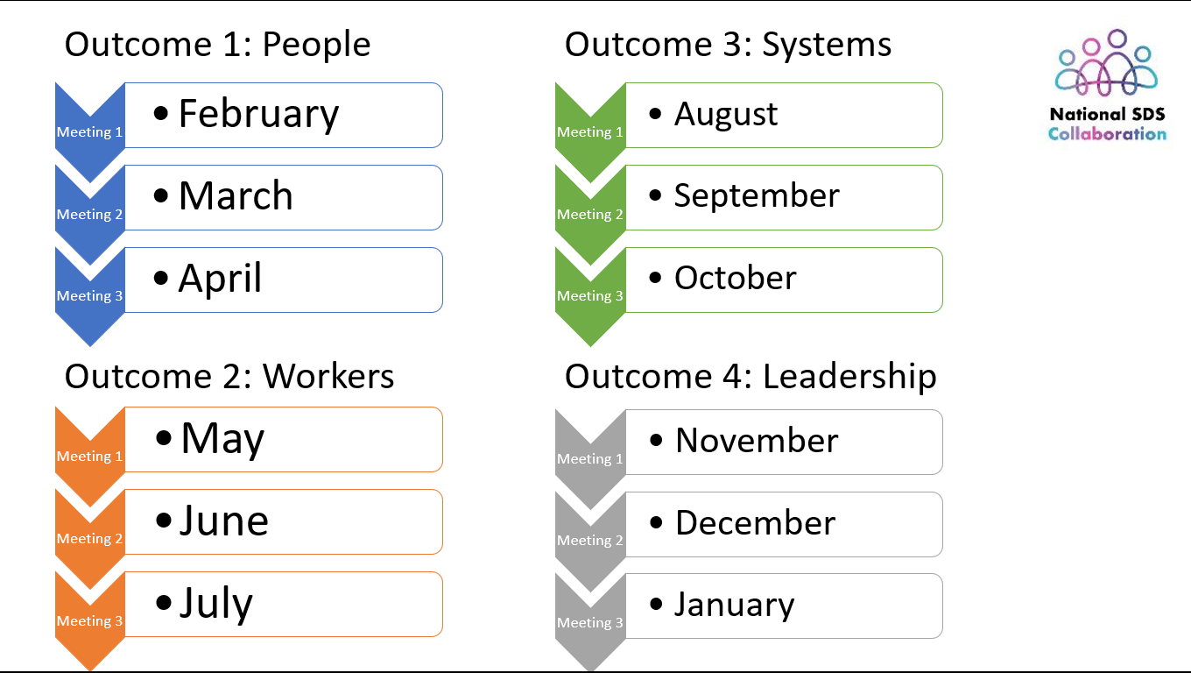

KH gave an update on the National SDS Collaboration website which is now live at https://nationalsdscollaboration.scot/ - this includes the statement of intent, and other sections including the “collaborate” page, to invite people to work with the NSDSC and how they can get in touch, and also a “meetings” page, which contains a reminder of the meeting dates and themes that will be covered in each meeting.

The website will also give access to the information pack that KP just talked about, as well as how to contact her.
The intention is also to video record each of the meetings going forward, and to share those recordings on the website also. This would include only the main body of the meeting, not the breakout groups. KH welcomed feedback, at: kayleigh@sdsscotland.org.uk

JK talked about the national SDS community of practice (SDS CoP) (see slide 6) and the intention to bring feedback from the workforce and implementers into the NSDSC space as well, in similar fashion to the model KP talked about earlier. A range of meetings associated with the SDS CoP is being planned for the next year, within the SDS project. More to follow in a future meeting.

AD gave an update on the SiRD project, which is included in the SDS improvement plan, though it predates the plan (see slide 7). SiRD organisations are funded across Scotland to support people to know their rights and to access them.

KH recapped some of the SDS related work that SDS Scotland have done (see slides 8 and 9), including overhauling their website to make it more accessible, including a “Get Help with SDS” page, which is now the most visited page on the SDSS website.
Following on from the SiRD slide, KH mentioned in connection with today’s theme (access to independent support, brokerage and advice) that SDSS had conducted research into this and found that while people really value independent support, there are still barriers facing some people who are trying to access this support. For more information, see: By My Side report (2024).
As part of looking into the barriers to access, SDS Scotland have also published a report about SDS for autistic people and this has led to some training for independent support organisations being developed to help them to think about how to support autistic people to access SDS, and work will be published soon looking at the barriers for those living with dementia and substance use.
As part of their programme of events, SDS Scotland also runs training throughout the year on a range of topics aimed at independent support organisations, to support people who work at these organisations to keep their knowledge up to date, and get support around emergent issues, e.g. guardianship.

KH also mentioned the work SDSS do on brokerage, an approach that's all about maximising people's natural supports, grounded in the values and principles of SDS. This is an approach that's proven increasingly important at a time when it's harder and harder for people to meet the eligibility criteria for self-directed support. This work has resulted in a co-produced National framework that defines the model of Community brokerage and sets out a blueprint of how to grow that model across Scotland. Community Brokerage also deliver a professional qualification verified by SQA that enables people working in and around SDS to improve their practice. There is also a community of practice or for those who have completed the award or who are working in a brokerage or independent support and information related role and this also contributes to their professional development.

PL gave an update from In Control Scotland (see slide 10), who have a particular interest in increasing the availability and flexibility of all self-directed support options for as many groups as possible. In Control are particularly focused on working alongside organisations to embed those principles of choice and control and flexibility. In Control have done quite a lot of work this year working alongside a few local authorities to look at how we embed flexibility in option 2 of SDS. This often identifies local rules and policies which are obstructing flexibility in practice. In Control are currently co-producing resources (covering things like financial management and responsibility and record keeping) to support independent support providers to deliver on SDS option 2, in response to feedback from providers last year.
In Control have also been working with one local authority to enable them to fund self-employed personal assistants (PAs) through SDS option 2, rather than through option 1 (where the supported person would be the employer), to make sure that all the appropriate checks and balances are in place to allow option 2 to be used to fund support in this way. In Control have also been doing some focused work looking at improving the level of flexibility that can be offered through SDS option 3.
In Control have also started to have early conversations to bring Children and Families along with regard to SDS option 2, and are also keen to consider development of a model brokerage contract to help streamline the process and allow better access to brokerage.

KH gave an update on the SDS handbook under activity 1.3 (see slide 11). This is now part of a suite of handbooks which are intended to be accessible as well as comprehensive, and are all available at https://handbook.scot/
Recently SDSS have been working on video content to be included in the handbook as well.

Reflection in discussion groups | Actions
The meeting broke into smaller discussion groups, to discuss:  Outcome 1: Supported person and carers’ choice and control over their support  1.1 Do supported people and carers have access to independent support, community brokerage and advocacy in your area? Tell us more about this.  1.2 Do providers of independent support, community brokerage and advocacy improve availability and flexibility of SDS options in your area? (For example, helping to develop the way option 2 is offered?)  1.3 Do you signpost the public to your independent support organisation for clear and accessible information about SDS?  1.4 What’s available in your area to support Personal Assistant employers?  1.5 What do you think needs to change?  Feedback from the groups –  - Capacity challenges, independent support organisations running waiting lists  - This pressure in turns means organisations can’t do good quality preventative work  - Increasing need for advocacy  - Gaps in access to advocacy across the country, sometimes across the same area  - Relationship between support organisations and local authorities could sometimes be better  - More availability of independent support and earlier access to independent support is needed  - More consistency in independent support availability is needed across the country  - Referral pathways and signposting – could these be improved?  - Consistency of quality of independent support across Scotland, and confidence in that consistency  - Preconception that advocacy is adversarial and is only for when things have broken down leads to people not getting access to advocacy at an early enough stage to be as useful as possible  - Very little support available for SDS option 2 recipients, focus is often on option 1  - Mixed picture of experience from those accessing SDS, particularly for the first time  - Some inconsistency even from visit to visit with the same worker, experienced by people accessing SDS  - Fear is common for people who are being given a review, or who are requesting a review, in case they lose some or all of their support  - Concern that decision-making is based on financial considerations, not personal outcomes  - Social workers not having time to engage with the kind of impact that decisions have on people  - How can we make sure that all workers have the requisite skills and understanding that they need in their role?  - Confusing language that we use around independent support. We have an inward-facing lexicon, but should we have an outward-facing one?  - Engaging with local Social Work – how easy is that?  - Capacity for SDS funded organisations (Social Work Scotland, SDS Scotland, In Control Scotland and Inspiring Scotland) to work together at a local level  - The patchwork nature of SDS funding for organisations  - Lack of transparency about what is funded and what is provided in each area  - The value of peer support, although that can be patchy, with precarious year-on-year funding.  - Public Health Scotland, lack of data on who has which SDS option, whether they wanted that option, and whether they were offered all four options, and how to start capturing that data.  - Positive feedback about the new format of the NSDSC meetings, since this will give the opportunity to focus on the outcomes in more detail from meeting to meeting, allowing all members to contribute  - Encouraging that Scottish Government and COSLA are engaged with this group and this work.  - The new format of the meeting feels more collaborative and useful, and it’s great to see a greater range of people engaging in this collaboration, and to have the opportunity for more action as well as listening at the meetings.  DMd reminded the group that the new website has a feedback mechanism, and encouraged members to use that to feed back on the format of these meetings, and anything that might help to shape the agenda for future meetings | Please use the feedback mechanism on the new website to feed back on the format, structure and agenda of these meetings going forward.

Current issues and dependencies | Actions
BA gave an update on the current issues and dependencies related to the SDS improvement plan.

- National Care Service Bill - part 1 of the Bill has been removed, having been replaced by a non-statutory Advisory Board. Part 2 and 3 of the Bill will go ahead, with stage 2 being completed by the end of March 2025. Opposition amendments are due in by mid-February.
- Access to Social Care (eligibility criteria) – The Access to Social Care team are at the beginning of a long process of option scoping on what eligibility criteria would look like in the future. This work ties in closely to the work of the SDS improvement team, as well as the SDS project workstream 5 group, on relationship-based practice, which the Access to Social Care team have now agreed to be represented on.
- GIRFE progress – SG improvement team speak regularly to the GIRFE development team. The most recent update is that the Team Around The Person toolkit has now received Minesterial approval and has now been published, and circulated to NHS Boards and local authorities, along with six drop-in sessions, to support embedding of the framework. There is the possibility for the GIRFE team to come to a future meeting of the NSDSC to talk about this work.
- Commissioning team are working towards ethical commissioning and statutory guidance, PL has now joined the commissioning working group.
- Digital developments – Much of the digital work which had been focused on the National Care Service is now focused within social care generally, so the SDS improvement plan continues to keep abreast of that work.

JK commented that the GIRFE toolkit is largely Health focused, without a lot of worked-through application of SDS. In the future, it might be a good idea to discuss putting a proposal forward for a self-directed support focus within the GIRFE frame of reference, and that work could take place within the relationship-based practice workstream (SDS project workstream 5), with links to, and consideration of, both GIRFE and access to social care.

BB talked about work with Strathclyde University, who are looking at person-centred approaches and research-based evidence to support practice, and they have struggled to find examples in social care, though it has been easier to find examples within healthcare.

MC also gave an update from a COSLA perspective.
- National Care Service - COSLA have met to consider the recent announcement about the NCS (see COSLA’s statement here). Council leaders are also keen to support the discussions around the the creation of the new NCS Advisory Board which provides an opportunity for greater national oversight.
- Recommendations of the Post-legislative scrutiny of the SDS Act – this report was published in Autumn of 2024, with several recommendations being made specifically to COSLA, as well as to other organisations, much of which was about embedding and mainstreaming good practice, as well as providing sufficient and appropriate training. COSLA are keen to work with those taking this work forward. COSLA have responded to these recommendations in December of 2024.

Any Other Business | Actions
Please see here for details of the forthcoming SDS National Voice conference - https://www.sdsscotland.org.uk/event/sds-national-voice-2025/

Please see here for the Alliance survey on SDS cuts - https://www.alliance-scotland.org.uk/blog/news/have-your-say-self-directed-support-cuts-and-reassessments/
And also this piece of research Sky News did with Scottish Care and counterparts which was published recently - https://news.sky.com/story/it-feels-like-we-dont-exist-the-human-cost-of-social-care-cuts-13294776

ILF has changed access to the re-opened fund in a significant way - the SDS budget level for access to ILF funds is now £485 per week if you have significant unpaid resident care. ie ILF Scotland will apply a notional amount up to £315 for unpaid care to enable people to reach the £800 SDS threshold which remains. This is good news as it will allow a lot more people to access ILF. Who can apply? | ILF Scotland

The next meeting of this group will be on Wednesday 5 March 2025 at 1pm.

