NATIONAL SELF-DIRECTED SUPPORT COLLABORATION
NOTE OF MEETING – 4th DECEMBER 2024

In attendance by video conference:
Donald Macleod (SDS Scotland) (chair) | Joanne McGee (Glasgow Centre for Inclusive Living) | Karen Procek (In Control Scotland)
Pauline Lunn (In Control Scotland) | Joanne Finlay (Scottish Government) | Billi Allen-Mandeville (The Alliance)
Kayleigh Hirst (SDS Scotland) | Leila Talmadge (Autistic Knowledge Development) | April O’Neil (Inclusion Scotland)
Beth Anderson (Scottish Government) | Gordon Dodds (Scottish Government) | Anna Shaughnessy (Inspiring Scotland)
Robert White (ILF Scotland) | Des McCart (Healthcare Improvement Scotland) | Elspeth Critchley (Encompass Borders)
Iain McGregor (VOCAL) | Les Watson (Personal Assistants Network) | Alicia Petrie (ENABLE)
Mark Han-Johnston (SDS Scotland) | Laura Hendry (Aberdeenshire HSCP) | Lyn Pornaro (Disability Equality Scotland)
Alastair Minty (In Control Scotland) | Ashley Drennan (Inspiring Scotland) | Brett Rogers (In Control Scotland)
Frank Reilly (SASW) | John Campbell (SWS Adults’ Standing Committee) | Morag Duncan (Dundee Carers Centre)
John Skouse (Care Inspectorate) | Becs Barker (Community Contacts) | Shannon McNee (Community Contacts)
Ruth Griffith (COSLA) | Laura Finnan-Cowan (Social Work Scotland) | Calum Carlyle (Social Work Scotland) (notes)
Welcome and Matters Arising | Actions
DMd welcomed the group.
Apologies were noted from: Rob Gowans, Iain Ramsay, Toria Fraser, Cheryl Taylor, Ekaterina Todorova, Claire Roxburgh, LizAnne McCahill, Eilidh Shearer, Kaye Robertson, Andy Miller, Pauline Boyce, Jane Kellock, Donna Murray, and Grace Macdonald.
The previous meeting minutes were approved by assent.
No matters arising.
DM intimated that the next meeting (15th January 2025) will have a focus on the monitoring and evaluation of the Self-directed support: improvement plan 2023 to 2027.

Statement of Intent Update | Actions
(double click to open)
The final draft of the Statement of Intent was circulated prior to the meeting. No amendments were proposed.

National Self-directed Support Collaboration Website | Actions
KH talked about recent proposals that a public-facing website be developed for the national SDS collaboration (NSDSC) to engage with people more widely and directly. Work has been done to develop a prototype website. The wording from the Statement of Intent has been used throughout the draft website, which KH presented to the group. This will give the NSDSC an online identity, for people to find out what the NSDSC does and to communicate more directly with the NSDSC.
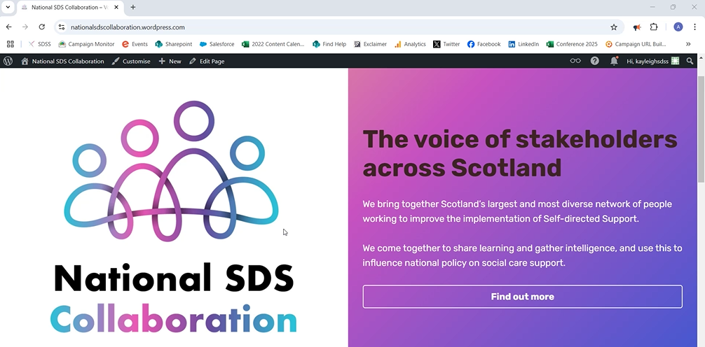

Comments and suggestions:
- Let’s make the website as inclusive as possible, not too corporate (eg the word “stakeholders” could be off-putting).
- It should also be as interactive as possible.
- Great that it will offer people an opportunity to be heard by the NSDSC without coming to the meetings, and the need to make it clear on the website that we encourage people to share their opinions.
- Let’s make sure the website is accessible, including for people who can’t interact easily with a contact form. If we really want lived-experience to collaborate with us, we need to make accessibility a central priority.
- There's a question over who/where that email or contact form goes to also.
- Are we setting ourselves up to fail? We need to be sure we have the resources
- Is there a plan for photos? It would be good to be real life rather than stock images.

Format of Future Meetings | Actions
The group split into smaller discussion groups to discuss progress in outcome area 1 from the Self-directed support: improvement plan 2023 to 2027 - supported person and carer’s choice over their support, where success means access to information, advice and advocacy, access to quality support, and control and involvement for supported people over how it is delivered.

The other three outcome areas from the Improvement Plan are set to be discussed at future meetings.

Some themes coming up in the discussion groups included:
- Hearing about variation of lived experience across Scotland
- Identifying what wasn’t working and what’s changed
- Market-shaping – difficulties between strategic planning and procurement and SDS
- Eligibility criteria as a barrier
- Good opportunity to link Scottish Government (SG) policymakers to lived-experience and practice.
- Making sure that services are accountable in the right way.
- Maybe initial meeting shouldn’t be on choice and control, as feedback might be deficit-focused.
- The need to be clear on what will be done with any information that is gathered.
- Back to basics on holding Social Work departments to account.
- Need to leave space for horizon-scanning.
- Recognition that ‘good practice’ is very dependent on local context, which can change very quickly.
- Collection and amplification of people’s experiences with SDS.
- Still not clear what expertise and experience some NSDSC members have to contribute, and it would be good to make the most of our members.
- Good idea not to rush through these outcome areas (eg quarterly discussion rather than monthly), give them the time necessary for consideration.

National SDS Stakeholder Updates | Actions
Social Work Scotland SDS project update –
Direct Payment Agreement for Employing Personal Assistants – this work has led to development of a thirteenth SDS standard, which will go to the Personal Assistants Programme Board (PAPB) tomorrow.

Seminars – Two seminars run recently (in partnership with Independent Living Fund Scotland and Personal Outcomes Network) have recently taken place, and videos can be accessed on our seminars page.

Rethinking Eligibility-Access To Social Care – Access to Social Care is a group hosted by SG looking at alternatives to eligibility criteria. The project team are involved with this work, and will continue to offer learning from our work as appropriate.

In Control Scotland update –
We are keen to collaborate with those who are already working directly with supported people and carers, yet we are keen not to add more work to you. We ask that if you already have a regular forum, space, or feedback mechanism with supported people and carers, you might consider being a link for information gathering from them to the National Collaboration and back to them. We aspire to ensure that local issues gain greater visibility and attention at a national level. If you would like to learn more and be part of ongoing discussions, can you please complete this form: https://forms.office.com/e/c25URUc8SJ

Three Action Learning Sets will be starting shortly for unpaid carers, from 10:30 to midday on the specified dates, it’s a space to reflect on what is working well, what isn’t working well, including discussion.
Members were asked to get in touch with In Control Scotland if they would like to get involved info@in-controlscotland.org.uk

Exploring Option 2 with Providers – The intention is to meet with providers twice in order to collate a range of guidance relating to SDS option 2. The meetings will take place on 6 February and 6 March. Contact Alastair.M@in-controlscotland.org.uk for more details.

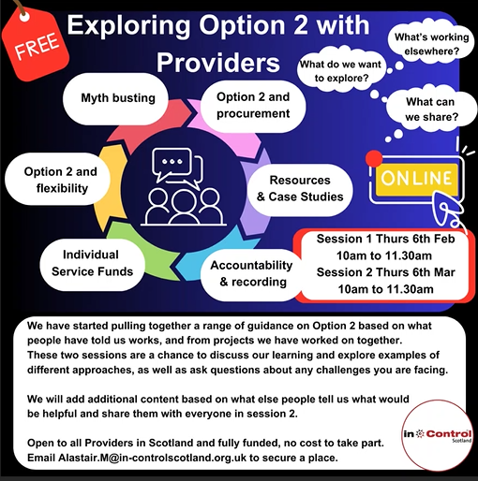

SDS Scotland update –
New research published by Self Directed Support Scotland has demonstrated the value people place on having independent help to access social care support. The By My Side research, conducted over March and April 2024, aimed to understand more about people’s experiences of accessing Independent SDS Support organisations (ISOs) across the country, such as Independent SDS Information and Support services funded through Support in the Right Direction, advocacy organisations and carers’ centres.
The research, conducted in the form of a survey, found that:
- 86% of respondents found independent support to be ‘Essential’ or ‘Very helpful’
- People accessed independent support from multiple ISOs during their social care journey
- Most people found out about independent support through their Local Authority
- Most people found ISOs to be accessible, to provide high quality support and to make a positive difference to them being able to access social care support.

PA Programme Board – The meeting tomorrow will consider the focus of the Board going forward.
Two new e-learning modules for Personal Assistants (PAs) are in development and will be launched early in the new year.

Tickets now available for the SDSS National Voice conference, which will take place on 19 March in Edinburgh. More information can be found here: https://www.sdsscotland.org.uk/event/sds-national-voice-2025/

Inspiring Scotland update –
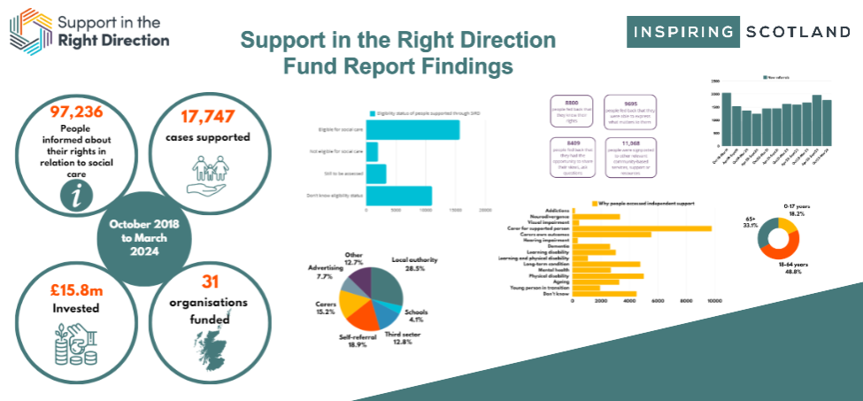
The new SiRD funding period has just started, and activities are being reviewed from SiRD projects with regard to the first six months of this financial year. A highlight report will be available early in the new year. The Support in the Right Direction fund report has just been submitted to SG, including data collected over five and a half years from 31 SiRD funded projects.

Learning coming from this ongoing research is that SDS is hugely beneficial to ensure that people have choice and control over their social care. Local authorities (LAs) are keen to collect relevant data to inform policy and practice going forward.

Scottish Government Updates | Actions
Post-Legislative Scrutiny – The first half of SG response to the recommendations relates to those recommendations which are not affected by the current developments National Care Service (NCS) concerns, however the second half of the response is everything that has a connection to the NCS. The response is not published yet, but has been received by Scottish Parliament.

SDS Grant Funding – Reports are being submitted to SG by SDS grant funded projects, to evaluate progress on the work being done, and to inform consideration of funding for next financial year.

Access to Social Care – The intention is to present the Minister with a full set of options by spring 2025, which will help to determine the direction of policy for the rest of the year.

Software As a Medical Device | Actions
Ruth Griffiths of COSLA gave a brief presentation about Software as a Medical Device, which affects a wide range of technological solutions due to a widening of the definition of “medical device”.

Medical devices in the UK are regulated by the Medical Devices Regulations (2002).
Following the UK’s exit from the European Union (EU), the UK Government and the Medicines and Healthcare Products Regulatory Agency (MHRA) are pursuing the opportunity to update the 2002 regulations under powers granted by the Medicines and Medical Devices Act (2021). The proposed changes will affect many aspects of how devices are regulated in the UK.
The MHRA are intending to instigate a definition for the word “software” in future regulation to provide clarity and to define scope. The definition proposed is: “a set of instructions that processes input data and creates output data”.
This will affect Local Authorities not just because they commission and purchase such devices, but also this will affect digital devices that people who are using services will purchase through their SDS budget.
COSLA and Scotland Excel have established a working group with stakeholders from Scottish Government and other organisations. The purpose of the group is to utilise past learning and to develop guidance for LAs to assist them with procurement, purchasing, contracting and management of software as a medical device and to identify and mitigate risks associated with the implementation of the new regulatory regime over the next 12 months.

Questions and discussion:
What kind of devices are included that someone with a direct payment would purchase? Would it include online platforms - such as around Personal Outcomes Planning or reminder and planning tools?
RG – The kinds of devices that would obviously be affected would be telecare devices and any devices that give alerts in response to monitoring. This can include eg. iPads, not necessarily specialist medical equipment. Other technology that is used in SDS will need to be considered in more detail, to inform development of straightforward national guidance that can be used by Local Authorities going forward.

The group broke into groups for fifteen minutes of open discussion about the topics raised in today’s meeting.

Any Other Business | Actions
BAM - We've heard from some of our members that people were being told that their care packages were being reassessed and that they should expect their support to be cut. It has also been shared that people are being told that local authorities are making pre-determined decisions and capping the amount they are giving people. For example, the maximum a council would pay for care was the cost of a care home placement. Attendees are welcome to share within the meeting or can contact me with their answers: Billi.Allen-Mandeville@alliance-scotland.org.uk

The next meeting of this group will be on Wednesday 15th January 2025, 1pm-3pm, looking primarily at the monitoring and evaluation of the SDS Improvement Plan.

